Cloud Trail & Cloud Watch
Task 1: Enable CloudTrail and Store Logs in S3 + CloudWatch
Step 1: Create an S3 Bucket
Example bucket name:
advanced-cloudtrail-logs-2026
Keep all defaults.
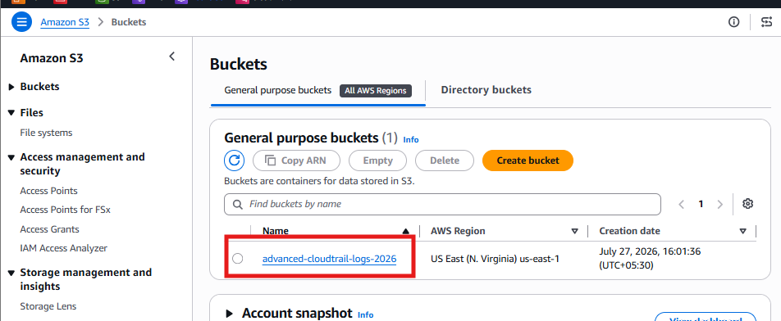

Step 2: Create CloudWatch Log Group
Go to
CloudWatch
→ Log Groups
→ Create Log Group
Name
CloudTrail-Logs
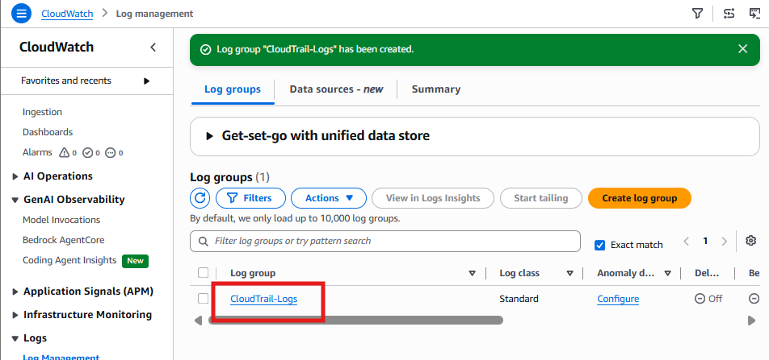

Step 3: Create IAM Role
CloudTrail requires permission to write logs.
Go to
IAM
→ Roles
→ Create Role
Trusted Entity
CloudTrail
Attach Policy
CloudWatchLogsFullAccess
Role Name
CloudTrail_CloudWatch_Role
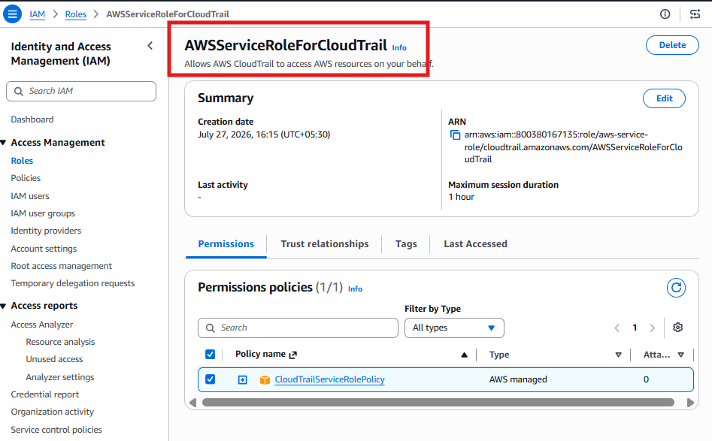

Step 4: Create CloudTrail
Go to
CloudTrail
→ Trails
→ Create Trail
Trail Name
Advanced-Trail
Storage
Choose
advanced-cloudtrail-logs-2026
Enable
✔ Management Events

✔ Read Events

✔ Write Events
CloudWatch Logs
Enable
Select
CloudTrail-Logs
IAM Role
CloudTrail_CloudWatch_Role
Finish.
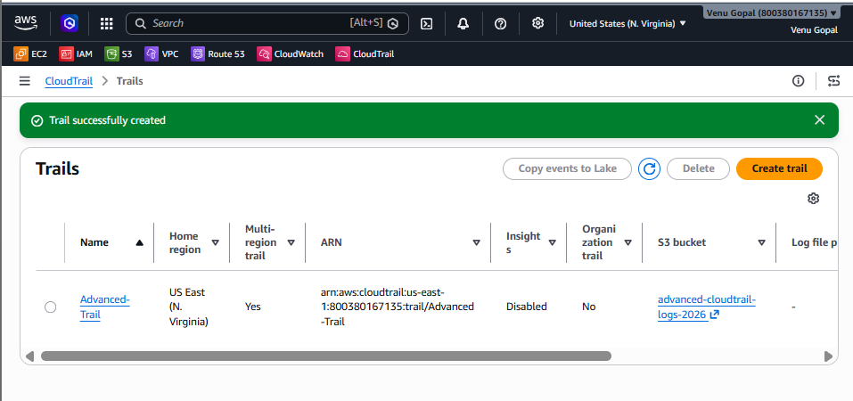

Result
Every AWS API call will now be stored in
S3 Bucket

CloudWatch Logs
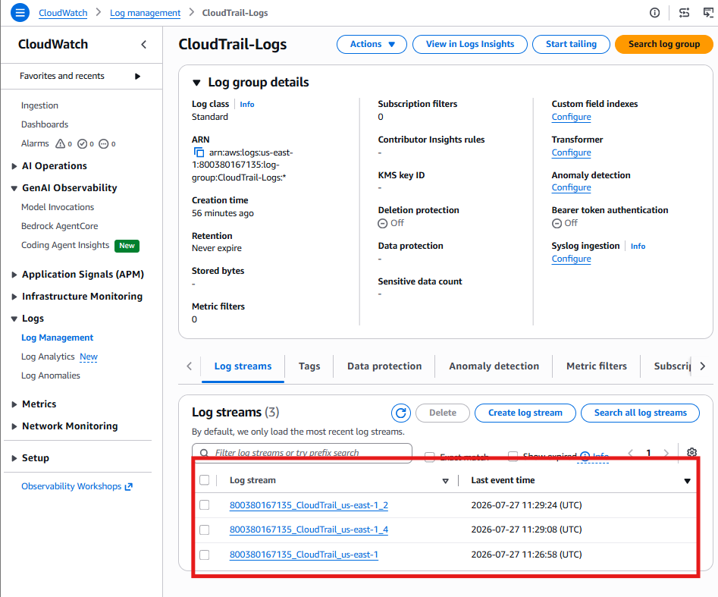

Task 2: Enable SNS for CloudTrail to Send Alerts via Email
You already created the SNS topic:
Alerts
Now we need to verify that it can actually send emails.
Step 1: Check Email Subscription
Go to:
SNS → Topics → Alerts → Subscriptions
Verify your email subscription.
The status should be:
Confirmed
If it says Pending confirmation
Open your email inbox and click the Confirm subscription link from AWS.

Step 2: Test SNS
Go to:
SNS → Topics → Alerts
Click:
Publish message
Enter:
Subject
CloudTrail Test Alert
Message
This is a test notification from AWS SNS.
Click:
Publish message

Step 3: Verify Email
You should receive an email similar to:
Subject:
CloudTrail Test Alert

This is a test notification from AWS SNS.
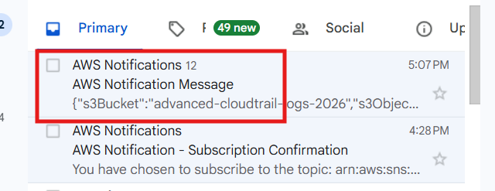
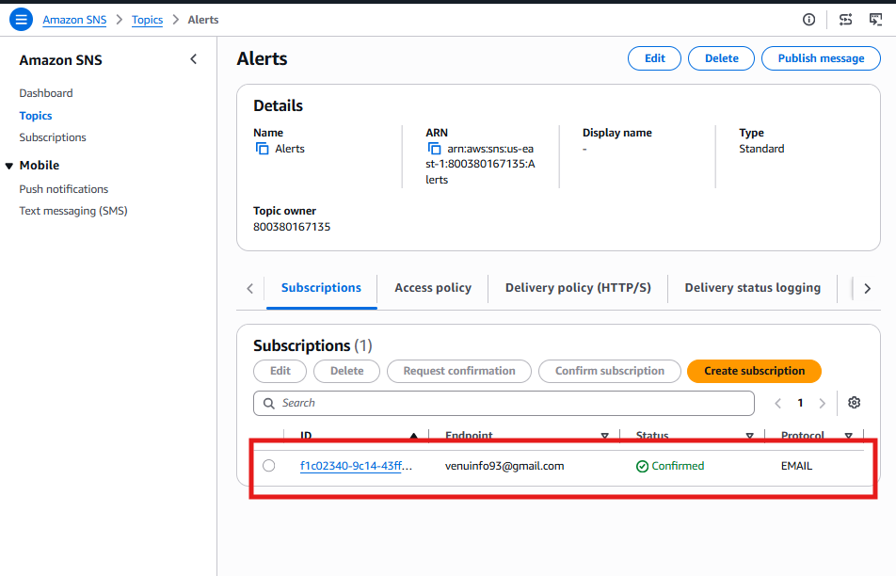

Task 3: Configure CloudWatch Monitoring for EC2
This task is about viewing EC2 metrics that AWS publishes automatically.
Step 1: Open CloudWatch Metrics
Go to:
AWS Console → CloudWatch → Metrics → All metrics
Select:
EC2
Then select:
Per-Instance Metrics

Step 2: Find Your EC2 Instance
Choose the EC2 instance that is running your Tomcat and Nginx services.
You should see metrics such as:
- ✅ CPUUtilization
- ✅ NetworkIn
- ✅ NetworkOut
- ✅ DiskReadBytes
- ✅ DiskWriteBytes
- ✅ StatusCheckFailed
- ✅ StatusCheckFailed_Instance
- ✅ StatusCheckFailed_System
These metrics are available by default from EC2.

Step 3: View the CPU Graph
- Tick the checkbox for CPUUtilization.
- A graph should appear.
- Change the time range (for example, Last 1 hour) if needed.
📸 Take a screenshot of the CPU utilization graph for your documentation.

Step 4: View Additional Metrics
Similarly, view:
- NetworkIn
- NetworkOut
- DiskReadBytes
- DiskWriteBytes
These satisfy the requirement to record CPU utilization and other EC2 metrics.

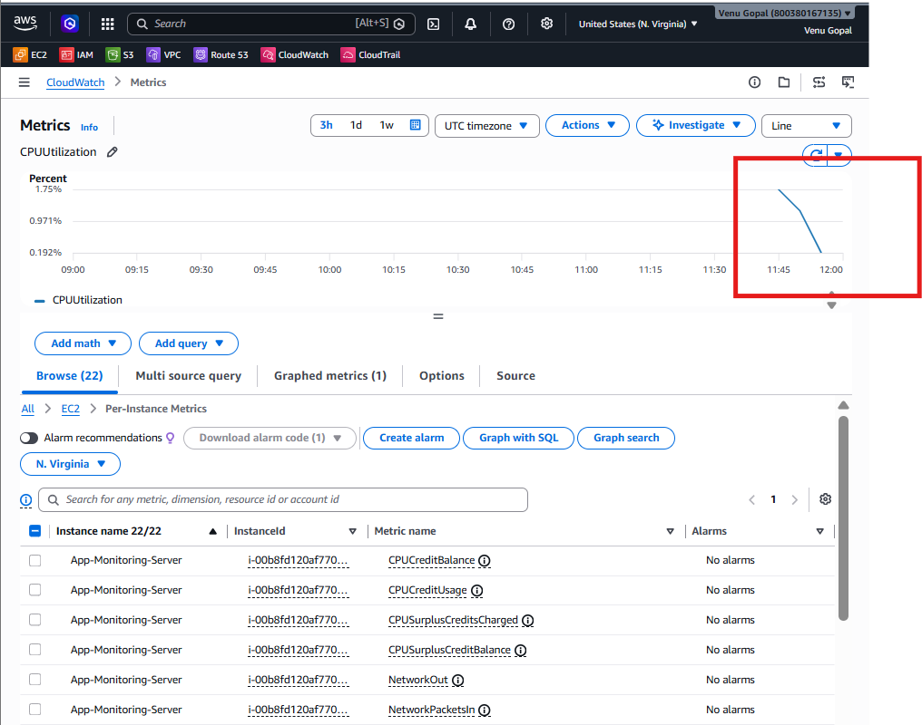
Task 4.Create one alarm to send an alert to email if the CPU utilization is more than 70 percent.

Step 1: Specify metric and conditions
Data source
- ✅ Metrics
Type
- ✅ Classic
Now click:
Select metric

In the Select Metric window
Navigate to:
EC2
→ Per-Instance Metrics
Find your instance:
App-Monitoring-Server
Select:
CPUUtilization
Click:
Select metric
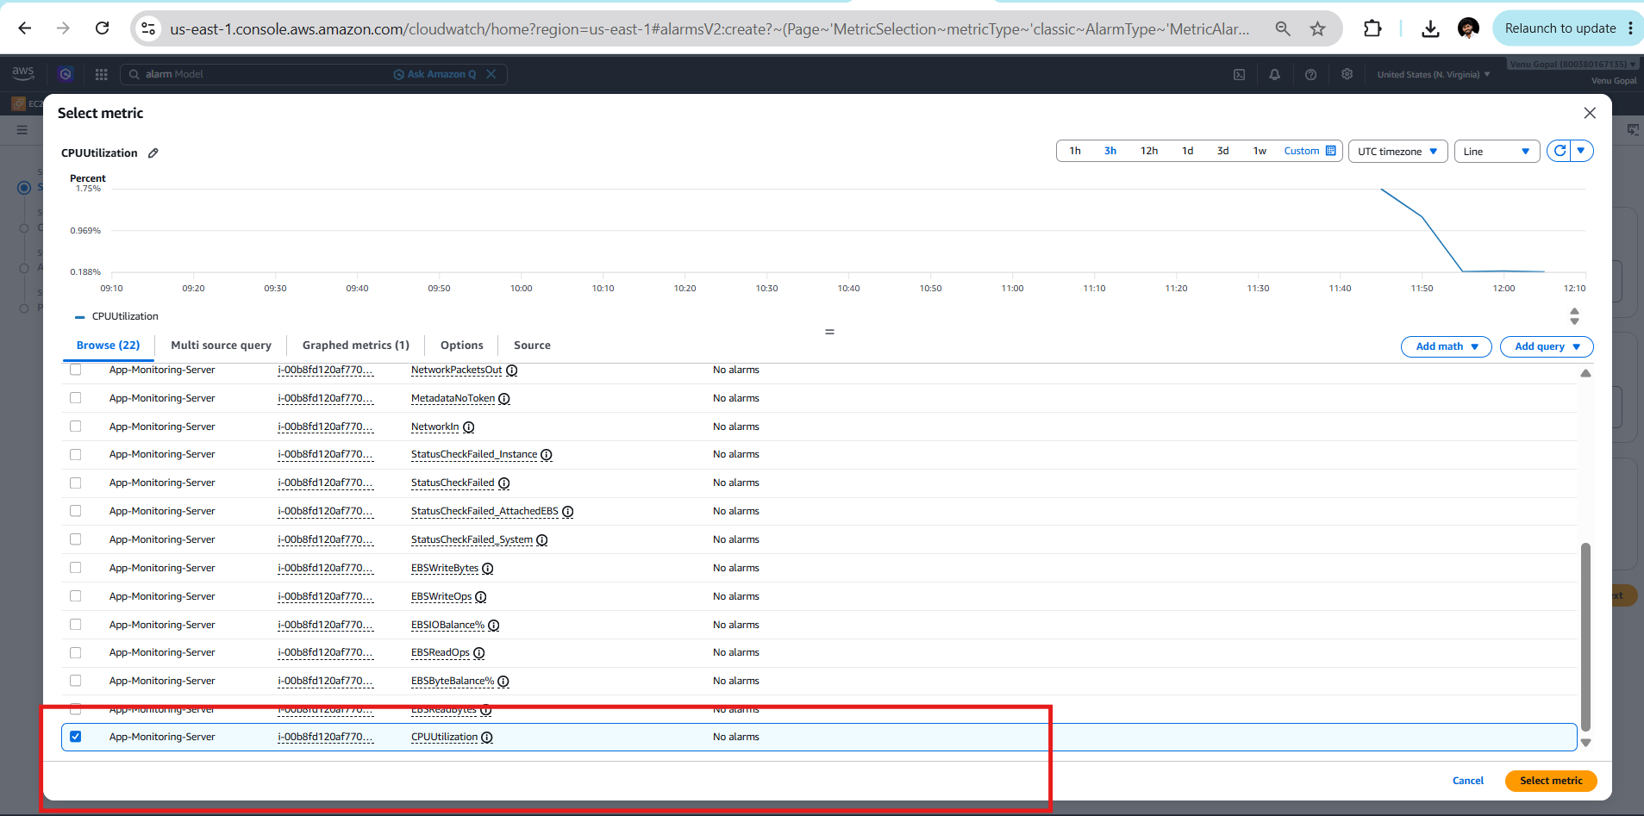

Configure the metric
Set the following:
Setting | Value
Statistic | Average
Period | 5 minutes
Threshold type | Static
Whenever CPUUtilization is | Greater than
Threshold value | 70
Click Next.
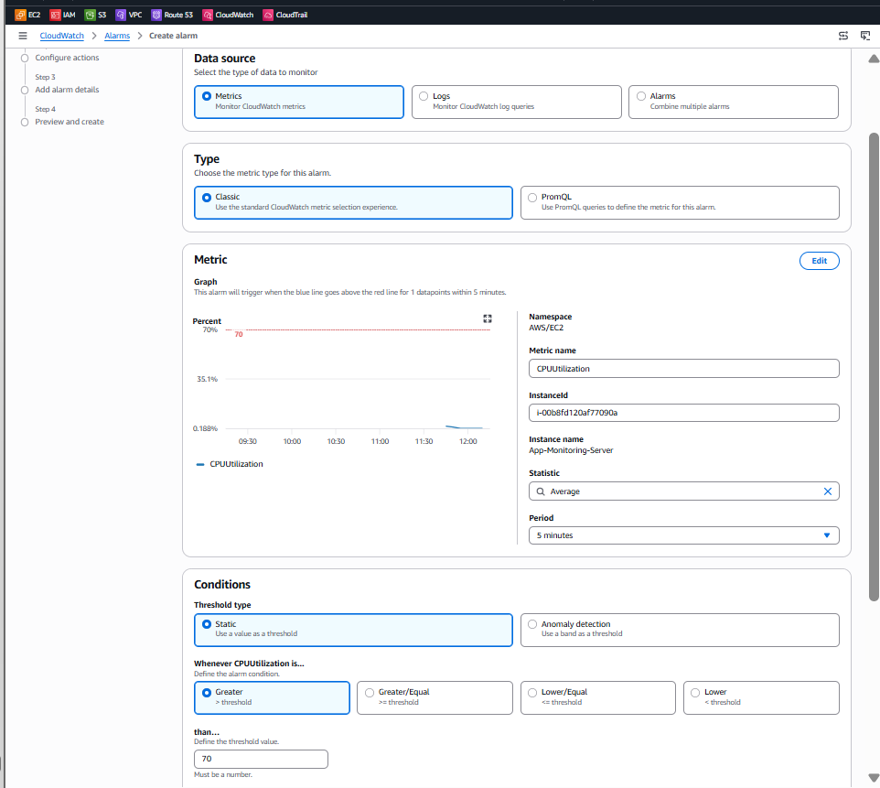

Step 2: Configure actions
Select:
- ✅ In alarm
Then:
- ✅ Send a notification to an existing SNS topic
Choose:
Alerts
Click Next.
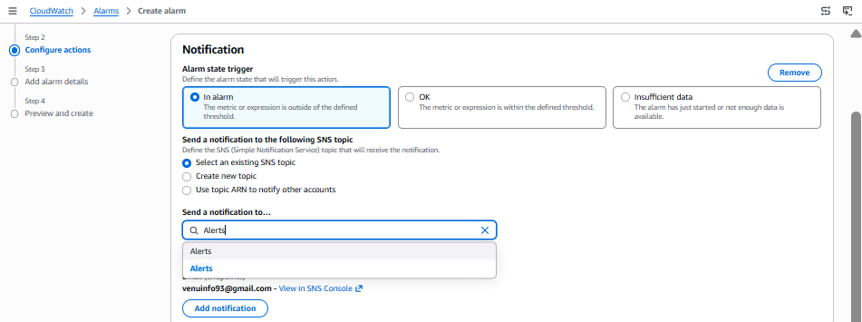

Step 3: Add alarm details
Alarm name
EC2-HighCPU-Alarm
Description
Alert when CPU utilization exceeds 70%
Click Next.
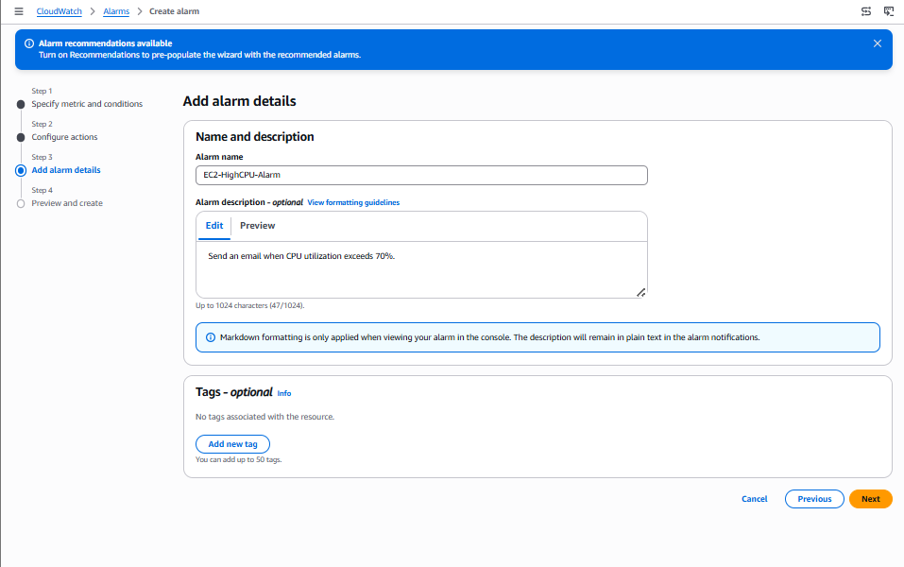

Step 4: Preview and create
Review the configuration and click:
Create alarm
